Analysis Report:

Comparing Dell Display Manager with Dell Display and Peripheral Manager

Kathia Villavicencio

Table of Contents
1. User-Centric Analysis and Recommendations for Dell Display and Peripheral Manager 2
1.1. Display Settings: 2
1.2. Input Source: 2
1.3. Easy Arrange: 3
1.4. Others: 4
2. New Features recommendation 5
2.1. Automatic Monitor Layout Detection and Seamless Mouse Movement 5
2.2. Enhance Screen Layout by Dividing Applications and Consolidating Tabs in the Same Window 5
2.3. Link the App to the Company Website for Product Comparison and Shopping 6
2.4. User-Centered Interface Customization 6
2.5. AI Assistant Chatbots for Improved Display Management 7
3. Recommendation for Walkthrough Design: 8

Analysis Report: Comparing Dell Display Manager with Dell Display and Peripheral Manager

User-Centric Analysis and Recommendations for Dell Display and Peripheral Manager

I have analyzed how I perceive the changes from Dell Display Manager to Dell Display and Peripheral Manager only for Displays as a home office user and provide recommendations for each option in the main menu.

Display Settings:

The integration of Brightness/Contrast, Color, and Display into a single Display Settings menu is a strong improvement because:
- The menu is streamlined, reducing complexities.
- A single button provides access to all display settings, making the function of this menu clear and intuitive.
Recommendation:
- Display Settings
  - Brightness/Contrast
  - Color
  - Properties
- Input Source
- Easy Array
- KVM
- Others

Dell Display Manager:
- Brightness/Contrast
- Input Source
- Color
- Display
- Easy Array
- KVM
- Personalize
- Others

Dell Display and Peripheral Manager:
- Display Settings
  - Brightness/Contrast
  - Color
  - Display Properties
- Input Source
- Easy Array
- KVM
- Others

Figure 1: Display Settings menu

I have one suggestion regarding the submenu: instead of labeling it "Display Properties," I recommend simplifying it to "Properties." The context already implies that these settings pertain to the display, so the shorter label would be more concise and still clear to the user.

Input Source:

According to the User Guidance, the Input Source menu allows you to manage multiple video inputs connected to your monitor, making it easy to switch between inputs while working on multiple computers. The KVM settings centralize all input-related configurations, simplifying the management of input sources and KVM switching. By definition, KVM options enable monitors with KVM support to connect to multiple computers through USB or network, allowing them to share a keyboard and mouse during setup.

Therefore, I recommend including the KVM option menu within the Input Source menu. Additionally, I suggest consolidating the General, PIP/PBP, and Hotkeys options into a single menu item called "Video." This would streamline the menu, focusing on video-related configurations that users typically adjust during setup. If users want to include keyboard, mouse, and other devices, they could simply click on KVM. I also recommend adding a tooltip or hover text for clarity.

In the Display Properties menu, if USB-C prioritization is only available for monitors that support this function, I would suggest simplifying the label to "Prioritization."

Recommendation:
- Display Settings
- Input Source
  - Video
  - General
  - PIP/PB
  - Hotkeys
  - KVM
- Easy Array
- Others

Dell Display and Peripheral Manager:
- Display Settings
- Input Source
  - General
  - PIP/PBP
  - Hotkeys
- Easy Array
- KVM
- Others

Dell Display Manager:
- Brightness/Contrast
- Input Source
  - General
  - PIP/PBP
  - Hotkeys
- Color
- Display
- Easy Array
- KVM
- Personalize
- Others

Figure 2: Input Source menu

Easy Arrange:

The "Easy Arrange" option in the menu was not intuitive for me. There is no tooltip on hover to explain what it does, which made it difficult to understand its purpose.
When I accessed the "Easy Arrange" option, I saw the layout choices, but there was still no explanation of what each layout represents.
I believe the experience could be improved by allowing users to select from a predefined number of windows—ideally up to three initially—and providing a button to add more layouts for additional windows if needed.
Additionally, I suggest placing the "Custom" option below the layout selection, followed by "Recent Layouts." The "Custom" option seems better suited for experienced users rather than beginners, so it should be presented in a way that reflects this progression in user expertise.

Regarding "Easy Memory," it is unclear what this feature means, what its purpose is, or what is meant by "Profile." There is no tooltip or hover text to provide clarification.
Now, I understand that "Profile" likely refers to creating a layout for a specific purpose, assigning programs, and scheduling a launch time. However, without further explanation, this is not immediately obvious to the user.

To enhance usability and clarity, I recommend renaming the "Easy Memory" feature to "Profile Manager." This name better conveys the feature's functionality, emphasizing its role in managing and restoring user profiles. Additionally, I suggest renaming "Layout" to "Screen Layout" to provide a more descriptive and user-friendly label, clearly indicating its purpose in managing screen arrangements. Finally, "Settings" could be renamed to “More settings” to present additional, less frequently used options.

Recommendation:
- Display Settings
- Input Source
- Easy Arrange
  - Screen Layout
  - Profile Manager
  - More Settings
- Others

Dell Display and Peripheral Manager:
- Display Settings
- Input Source
- Easy Arrange
  - Layout
  - Easy Memory
  - Settings
- KVM
- Others

Dell Display Manager:
- Brightness/Contrast
- Input Source
- Color
- Display
- Easy Arrange
  - Layout
  - Easy Memory
  - Settings
- KVM
- Personalize
- Others

Figure 3: Easy Arrange menu

Others:
In the User Guidance, it is understood that Application Settings has two functions: export and import. These functions allow you to export the monitor settings from one monitor and import them into another monitor of the same model. However, it should be clarified which specific settings these functions refer to.

New Features recommendation

When recommending new features, I consider the target users outlined in the Product Requirements Document (PRD):
- IT Professionals: Enterprise IT and IT Support staff.
- Business Users: Productivity-Driven professionals and Comfort-Focused Users.
- Home Users: Home Office Enthusiasts and Tech-Savvy Individuals.

Automatic Monitor Layout Detection and Seamless Mouse Movement

As a home office user, one of the recurring pains points I've encountered is locating the mouse cursor when using multiple displays with a single PC. For instance, when I bring my laptop home, I might position it on either the left or right side of my primary display. If the laptop was previously on the left, the mouse naturally moves from left to right. However, when the setup changes, it’s frustrating to manually adjust to the new mouse position. This issue becomes even more complex when multiple PCs are connected to the same display setup.

To address this, I'm considering a feature that enables seamless mouse movement across screens based on their physical arrangement, without requiring manual adjustments in the Windows Display Settings. We can achieve this process as follows:

- Monitor Layout Detection: Using an API to detect display positions.
- Mouse Movement Logic: Mapping mouse movement across screens based on their physical layout, possibly through a custom driver or software layer that integrates with the KVM.

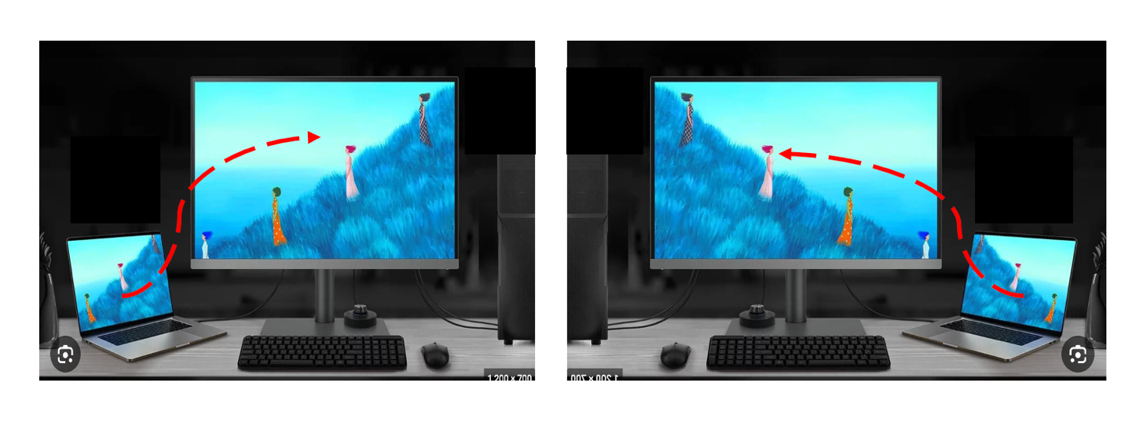Figure 4: Automatic Monitor Layout Detection and Seamless Mouse Movement

Enhance Screen Layout by Dividing Applications and Consolidating Tabs in the Same Window

I was considering an enhancement to the Easy Arrange feature that would allow users to divide their monitor into a layout of two or more windows, organized by application, with the option to view open tabs. The idea is to provide a feature where a user can assign one application, such as Outlook, to a specific window and have all the relevant tabs or instances consolidated there. Simultaneously, another window could host a different application, like Edge, with all its tabs organized in that space.

Currently, Easy Arrange allows users to organize multiple applications on a single monitor by dividing the screen into predefined layouts. This enhancement would further empower users to manage their workspace by assigning specific applications to designated windows within the layout. The goal is to streamline multitasking and improve overall efficiency in a multi-window environment.

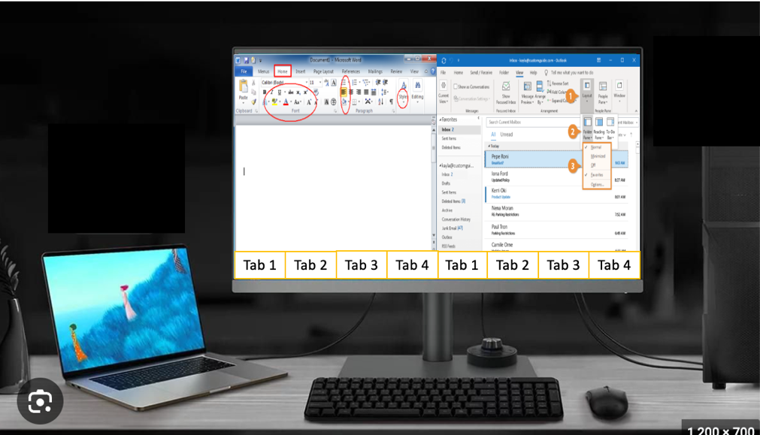

Figure 5: Enhance Screen Layout by Dividing Applications and Consolidating Tabs in the Same Window

Link the App to the Company Website for Product Comparison and Shopping

Introduce a menu option called 'New Products.' This feature allows users to compare the product they are currently using with other available models from the same brand. It could be linked to the Dell.com site, enabling users to explore how newer products might offer better performance, features, or value, and seamlessly purchase these products from the website. This feature not only enhances the user experience by providing personalized product recommendations but also serves as a call to action, encouraging users to explore and buy.

Implementation Details:

Product Comparison Engine:

Functionality: Integrate a comparison tool within the software that analyzes the user’s current product specifications and compares them with other available models on the company’s website Dell.com. The tool will highlight improvements in key areas such as Response time if it’s a gaming user, allowing users to make informed decisions. If they choose to purchase a display, they are directed to the website’s shopping platform.

Target User Customization:
- Business Users: Emphasize productivity improvements, such as higher native resolution for multitasking or better ergonomic design by comparing display position adjustments.
- Home Users: Focus on entertainment and gaming enhancements, such as improved response time, additional input connectors for various gaming consoles, or a larger screen size.

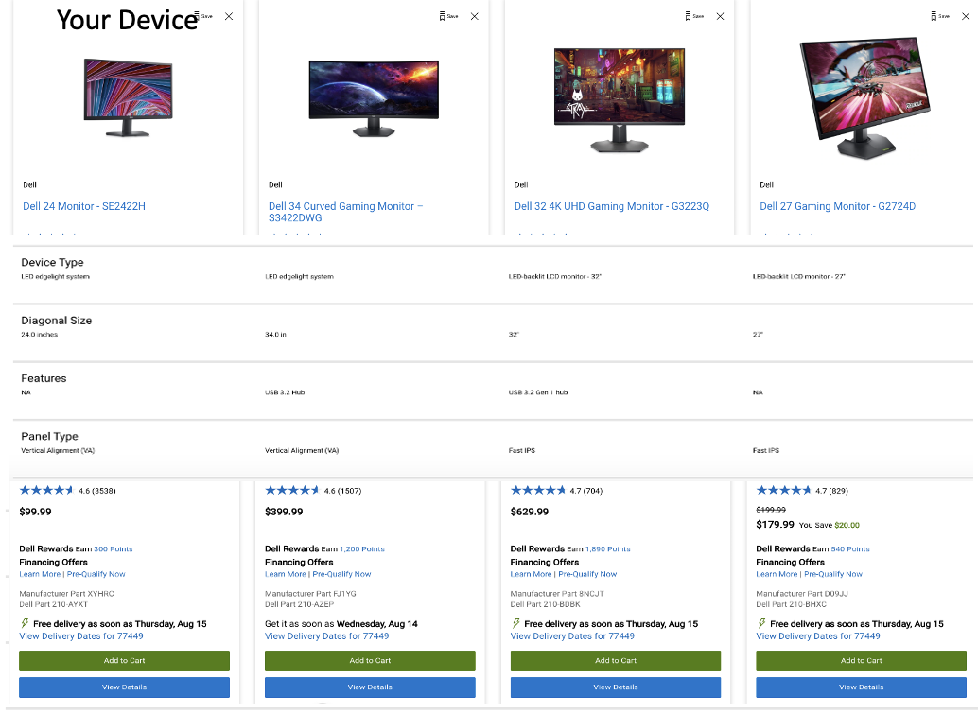

Figure 6: Link the App to the Company Website for Product Comparison and Shopping

User-Centered Interface Customization

It's essential to create a user experience that aligns with the diverse needs of the target audience. By allowing users to self-identify their role or primary use case, you can dynamically adjust the software interface to emphasize the most relevant features for each user type. This approach not only streamlines the user experience but also enhances efficiency by reducing the time users spend searching for the tools they need.

User Identification:

During the initial software setup, a brief onboarding process will ask the user to identify their role or primary use case. This can be done either through a direct question or a drop-down menu. For example:
If it's a question: "What is your primary use case for this software?"
If it's a drop-down menu: Provide options such as:
- Business User focused on Productivity
- Business User focused on Comfort
- Home Office Enthusiast
- Tech-Savvy Individual or Gamer
UI Prioritization:

Based on their selection, the software will prioritize the features that are most important for each target user, as defined in the PRD (Product Requirements Document). The features that are a priority for the user will be placed at the top of the menu and highlighted with a distinct color to facilitate easier navigation.

For example, important features for each user type might include:
- Business User focused on Productivity: For this group, the Easy Arrange feature, particularly Layout optimization, would be prioritized. This feature would be highlighted in the menu, allowing users to quickly organize their workspace for maximum efficiency.
- Business User focused on Comfort: Display settings such as Color and Brightness/Contrast. These users often prioritize eye comfort and visual clarity, so these settings would be placed prominently in the interface.
- Home Office Enthusiast: Display settings such as Color and Brightness/Contrast.
- Tech-Savvy Individual or Gamer: Gaming features, including Game Enhance Mode and Color Presets.

AI Assistant Chatbots for Improved Display Management
Integrating an AI assistant chatbot for display management can significantly enhance the user experience by providing personalized, real-time assistance and simplifying complex tasks. The chatbot would allow users to easily adjust settings like brightness, contrast, input sources, and color profiles through natural language commands, reducing the need to navigate through complicated menus. It could also proactively offer tips and suggestions based on the user’s current activity or environment, such as optimizing display settings for different lighting conditions or switching to gaming mode. By learning from user interactions over time, the chatbot would continuously improve its responses and recommendations, making the software more intuitive and accessible for a diverse range of users, from IT professionals to home office enthusiasts. This integration not only streamlines the user experience but also enhances productivity and satisfaction by making display management more efficient and user-friendly.

Recommendation for Walkthrough Design:
For the Easy Memory feature, the walkthrough should begin by clearly explaining what a "profile" is, particularly in the context of screen profiles. It’s important to define this upfront so users understand the concept they’re working with. I recommend including images or small visual aids throughout the walkthrough to visually represent what the Easy Memory feature aims to achieve. This will help users quickly grasp the functionality. The walkthrough should then guide users through the setup process step by step:
For the USB KVM setup, I recommend using the term "computers" instead of "devices" to avoid confusion, as "devices" could refer to peripherals like keyboards and monitors. It’s crucial to be explicit about what needs to be connected, ensuring users understand the exact steps and hardware involved. Additionally, when setting up PIP/PBP, it’s important to clearly explain what these terms mean and how they affect the display. This will help users make informed decisions and better utilize the feature.
Example Approach:
There should be a button labeled "Onboarding" that directs users to the walkthrough. This should start with a welcome screen that introduces the user to the interface and collects any necessary information upfront. Following this, an onboarding checklist can guide users through the setup process, motivating them with progress indicators and checking off completed tasks. Tooltips should be used to showcase key features as users progress, allowing them to get started quickly with the most important functionalities. This approach ensures that users feel supported and confident as they explore and configure the software.

